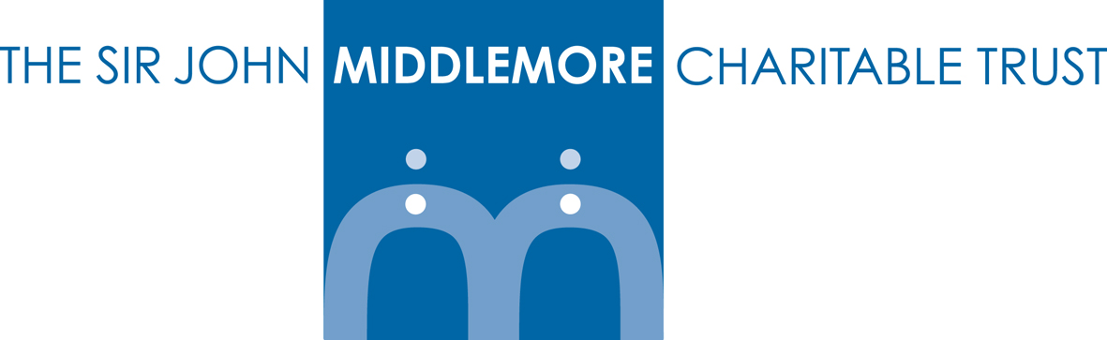

How The Trust Works

The Trust is relatively small and grants are usually up to £2,000 per application.

Support is focused on organisations based in Birmingham and the surrounding West Midlands Region who work with disadvantaged children and young people under 18 or with a disability under 25.

Applications can be made by not-for-profit organisations. The Trustees/Directors are particularly keen to support smaller organisations with an annual income of less than £250,000. Projects that have an annual income of less than £250,000 but exist within a voluntary/statutory organisation with an income of more than £250,000, can apply but must have a distinct ring-fenced bank account either in their project’s name or held in restricted funds within the organisation’s audited accounts.

All grants are made at the discretion of the Trustees/Directors who meet four times a year in January, April, July and October to consider and allocate funds. Their decision is final.

We do not make grants in response to applications received in the form of general appeals or mail shots.

How to apply

Grant Application Forms can be downloaded from our website www.middlemore.org.uk or requested via e-mail office@middlemore.org.uk

We would prefer completed application forms to be returned via e-mail however if you are unable to return via this method hard copies can be posted to the Trust Administrator, PO Box 7228, Stourbridge DY8 9FZ.

Rejected applications cannot be resubmitted within a 12-month period without substantial additional information.

An evaluation report must be completed at the end of the funding period. Failure to complete the report will result in the organisation being unable to apply for any further funding until the completed evaluation report has been received.

Who can apply?

- Registered Charities
- Unincorporated Charities
- Community Interest Companies
- Community Groups providing they have a constitution and produce accounts
- Not-for-profit organisations

The Trust Supports

Requests for funding will be clearly of direct benefit to disadvantaged children and young people under 18 or with a disability under 25.

Trustees/Directors are keen to support local projects and particular areas of interest include:

- Disabled children and young people
- Looked after children and young people
- Looked after children and young people leaving care
- Young Carers
- Disadvantaged children and young people

The Trust Does Not Support

- Organisations/Projects with an annual income over £250,000 per annum
- Organisations/Projects with unrestricted reserves of more than 6 months operating costs
- Political organisations
- Medical treatment or research
- Applications from individuals

