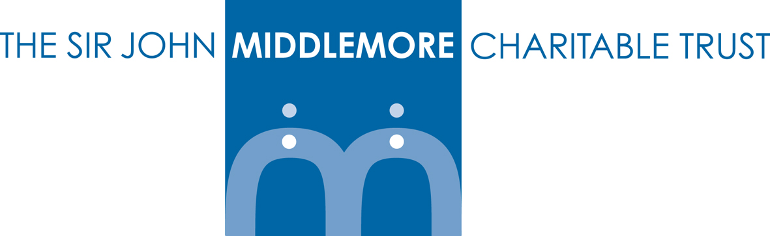

GRANT APPLICATION FORM

Name of Organisation:
Name of Person Applying:
Position in Organisation:
Address:

Telephone Number
Landline: |  | Mobile:
E-mail address:
Website:
Charity Registration Number:
Company Number:
Describe the aims and activities of your organisation:

Why are you applying for a grant?

What is the total amount of the project?
What amount are you applying for?
Breakdown how the grant will be spent.

If the funding requested is not the full project cost how are you funding the difference?

What success in fundraising have you had in the last 12 months? Give details.

How many children will benefit from the project?
Which age range will the project benefit?
Which post code areas will your project serve?
Have you approached The Sir John Middlemore Trust before? Please give dates and amounts of any grant awarded.

How did you hear about The Sir John Middlemore Trust Fund?

If successful, the grant payment will be made by bacs. Please provide:

Bank Account Name:
Account Number:
Sort Code:

Please attach a signed copy of latest audited or independently examined accounts.

If the form is incomplete, or attachments requested not included, your application may not be considered.

Completed application form should be e-mailed to office@middlemore.org.uk

Declaration

I agree to abide by the terms and conditions of the grant as they are set out in this application form and understand that any offer of a grant will be subject to the proposed work remaining within that grant criteria. I agree to participate in monitoring, auditing and evaluation related to this grant.
Data Protection

The Sir John Middlemore Trust will use this information only for the purposes of assessing your application, managing or monitoring any grant awarded and related administration. Your information will be kept strictly confidential and will not be used for any other purposes or disclosed to any third party.
Information may be retained for up to 6 years, in accordance with our data retention policies, after which time it will be destroyed.

Please tick the ‘I Agree’ box below to confirm you have the authority to apply for this funding and consent to these terms and conditions on behalf of this organisation.
I Agree | ☐
Name
Date

